**RAVE KT SESSION DOCUMENTATION**

1. **RAVE val url :** <https://avdev.mdsol.com/>

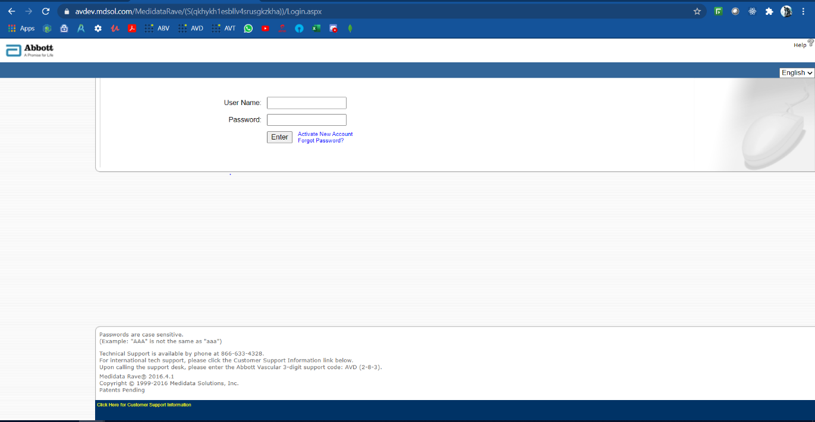

Login page view

1. **The Home page:**

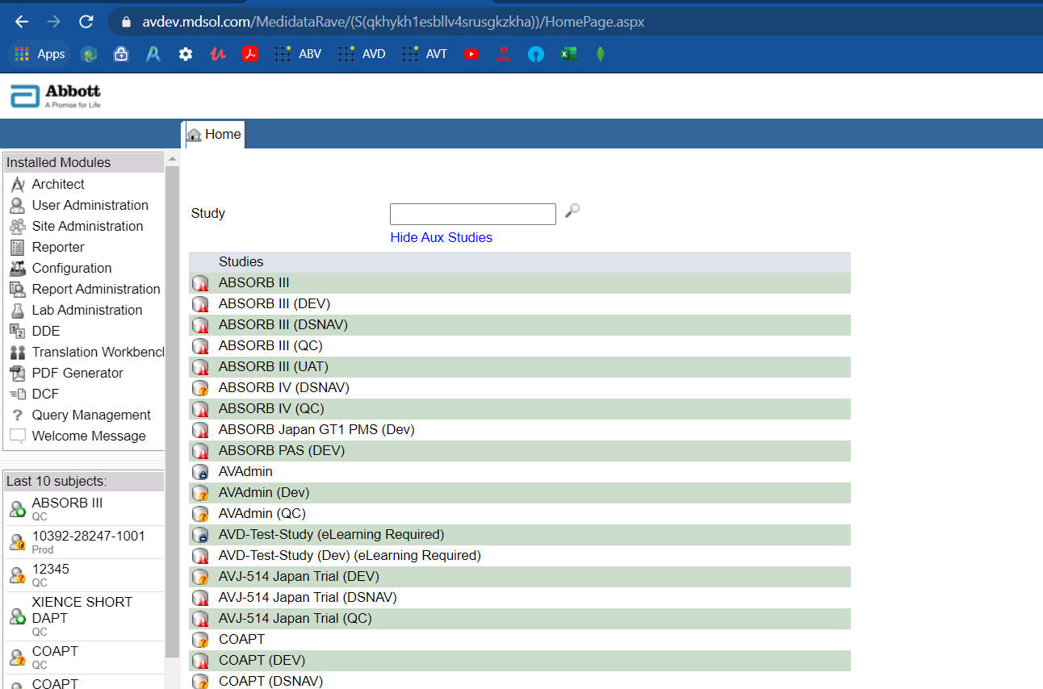

Home page view

1. **The Study hierarchy:**

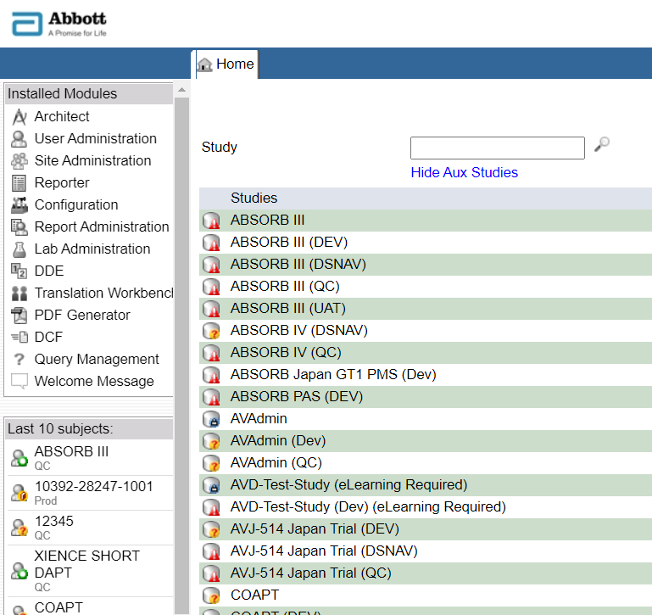 Studies Sites Subjects Folders Forms

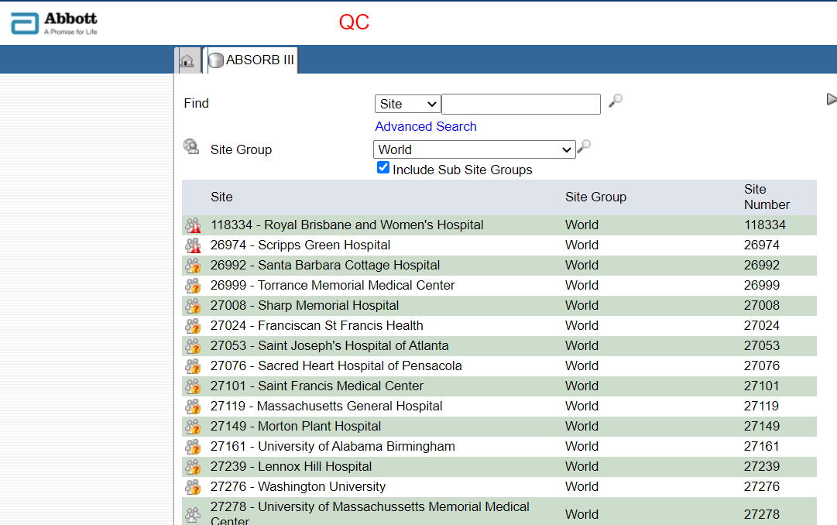

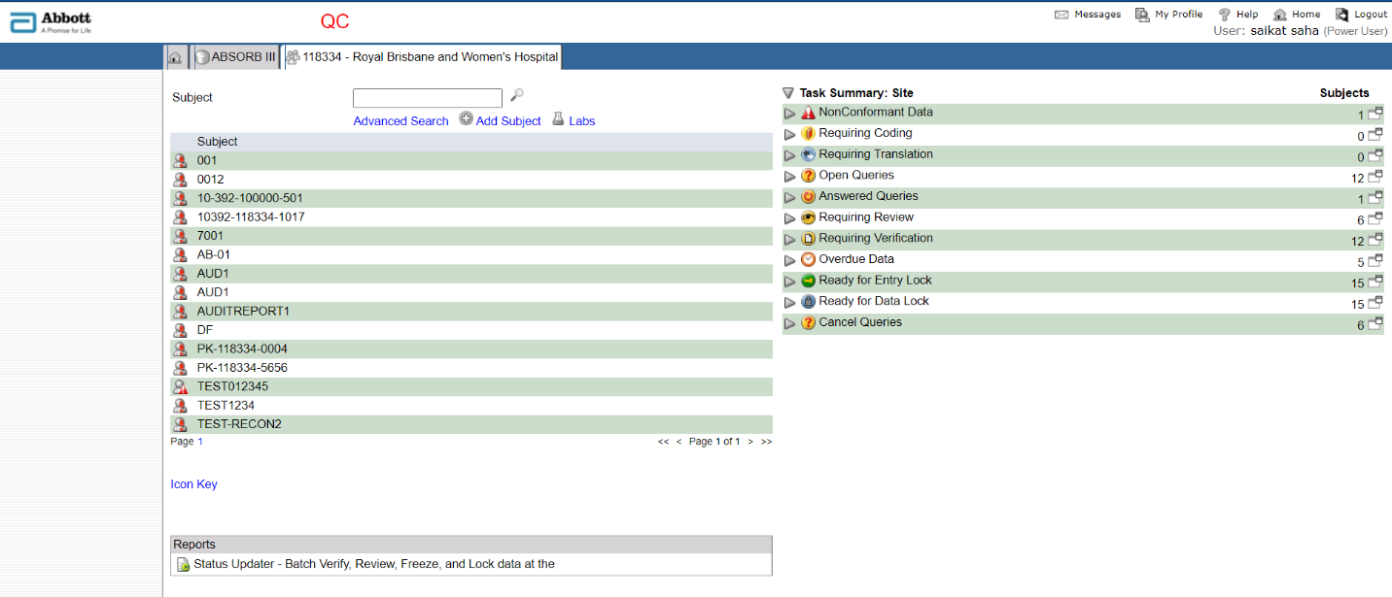

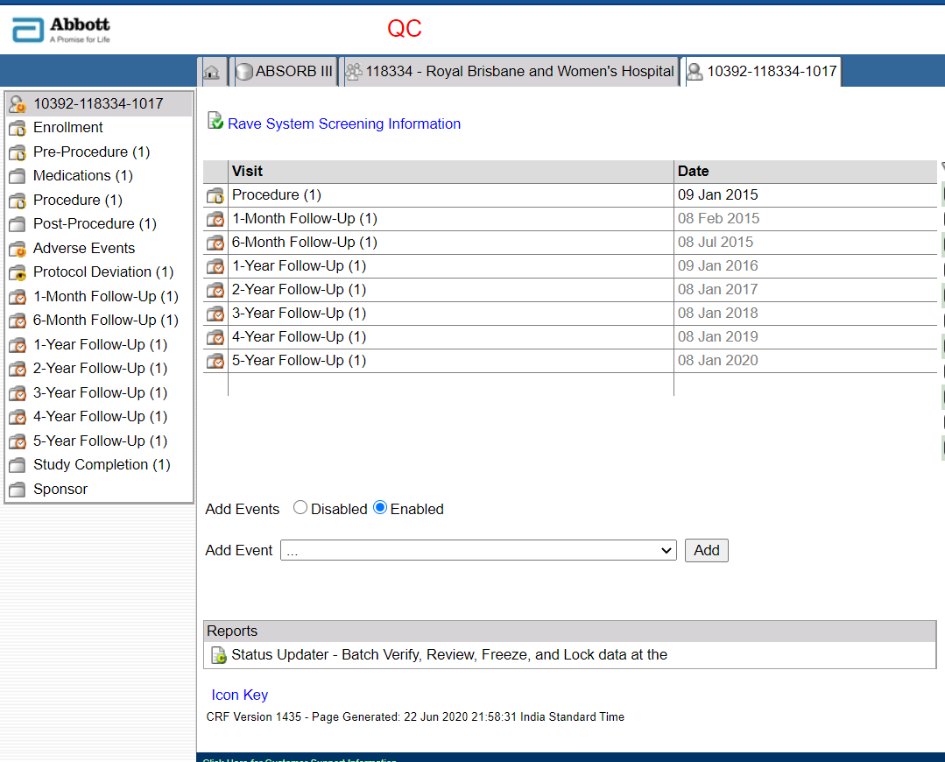

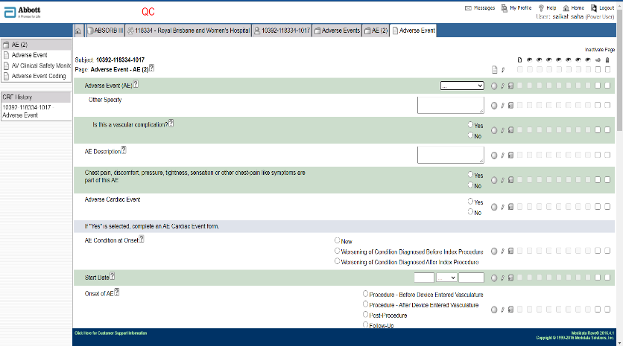

1. **Subject Enrolment page:** Creating/enrolling a subject is done from Subject list page, by clicking into the “Add Subject” button.



1. **Subject enrollment :** While creating a subject the subject number must be given to distinguish a particular subject.

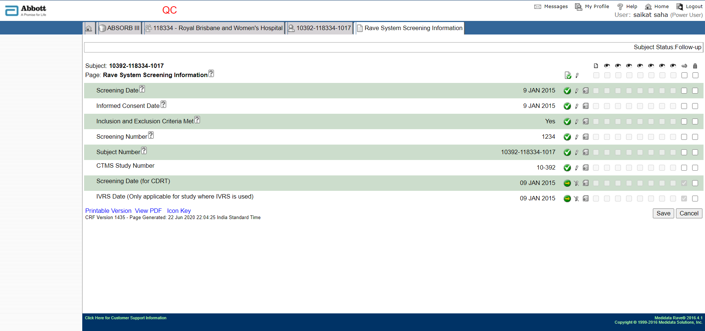

After successfully filling the form click to save or cancel to not to save the data

1. **The data that is the point of interest:**

From Rave to recon only three types of data flow.

1. Adverse Event data ( AE data).
2. Device Malfuction data (DVD data).
3. Demographic data (DM data).

Other than these three type of data no other form need to be filled as they would be the waste of effort cuz ultimately they wont be going into the recon system. In recon system the data received in XML format.

1. **Types of data that flow into recon :**

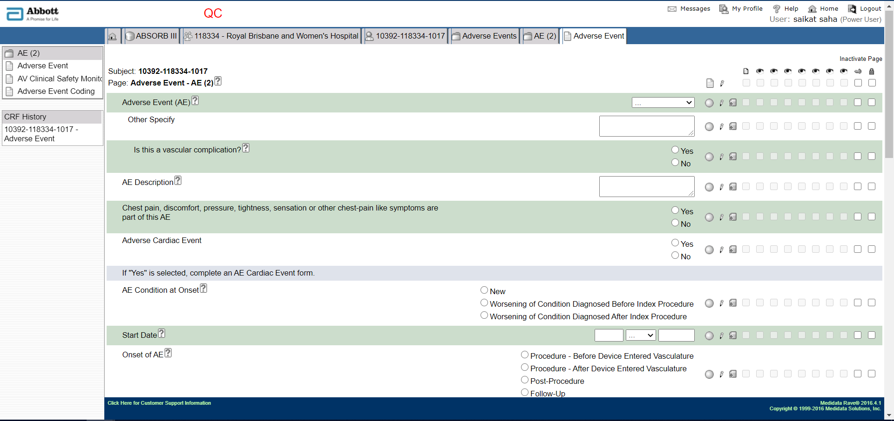

Figure 1 Adverse event from

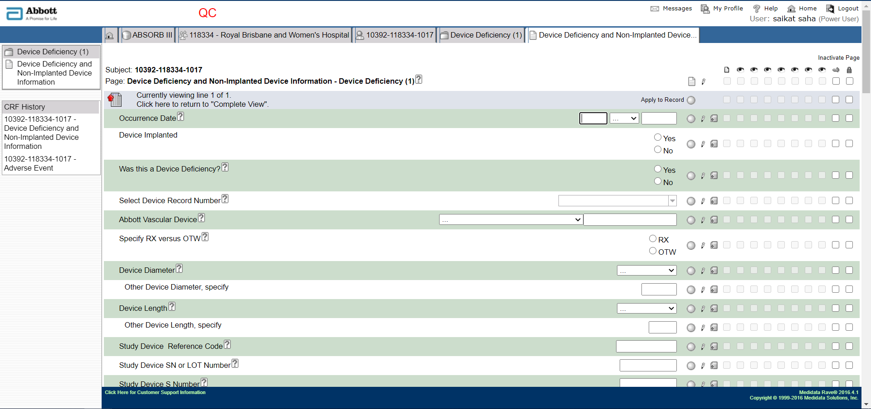

Figure 2 Device Malfunction form

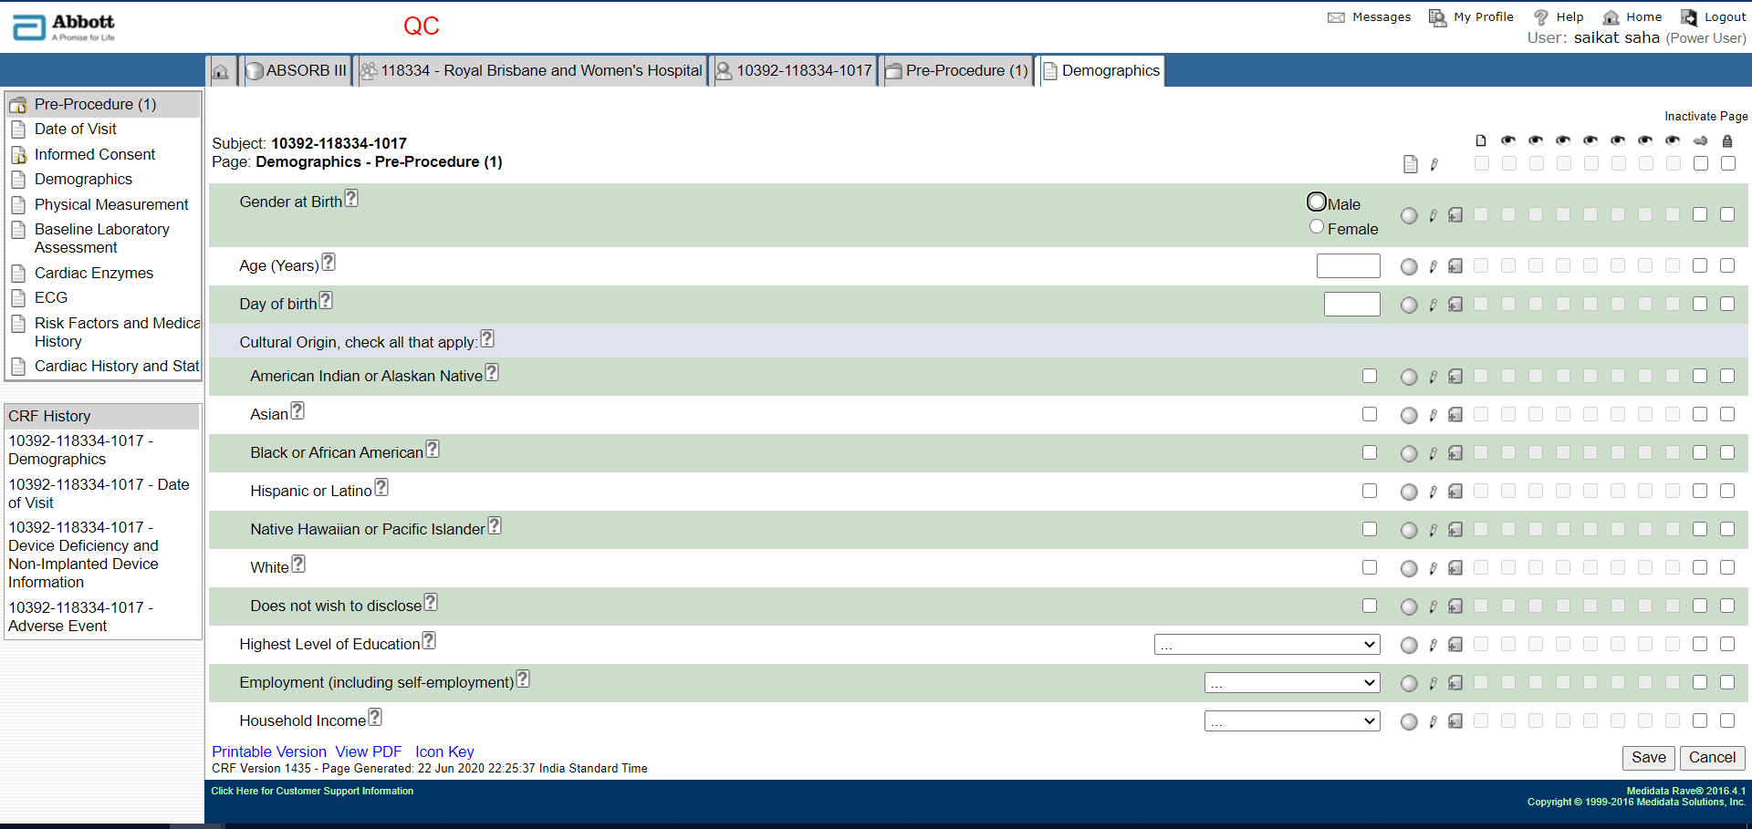

Figure 3 Demographic form

1. **Different types of forms:**

There are specifically two types of forms existing in RAVE interface.

1. Regular Form : Where you can enter a single set of data, and most of the forms are regular forms e.g. AE form.
2. Log Form : Where you can enter multiple sets of data. While entering they will appear like a regular form but after saving it will appear like a list, more like a log view of different actions e.g. DVD form

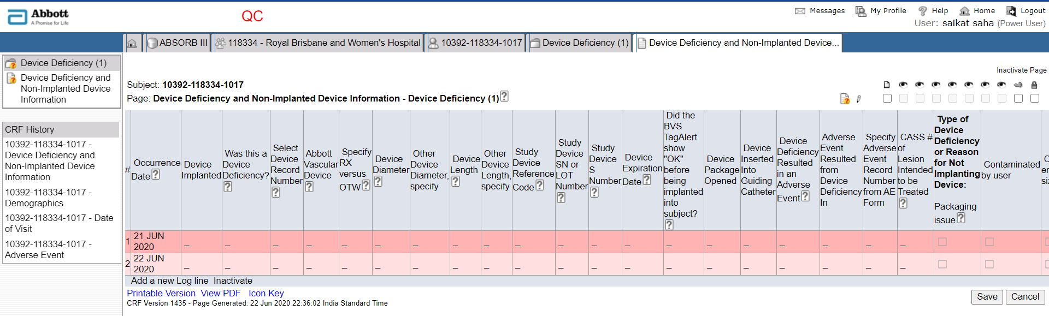

Figure A typical log form

You can add a new log line by clicking this option

1. **Adding Adverse Event and Device Deficiency form in to the subject :**

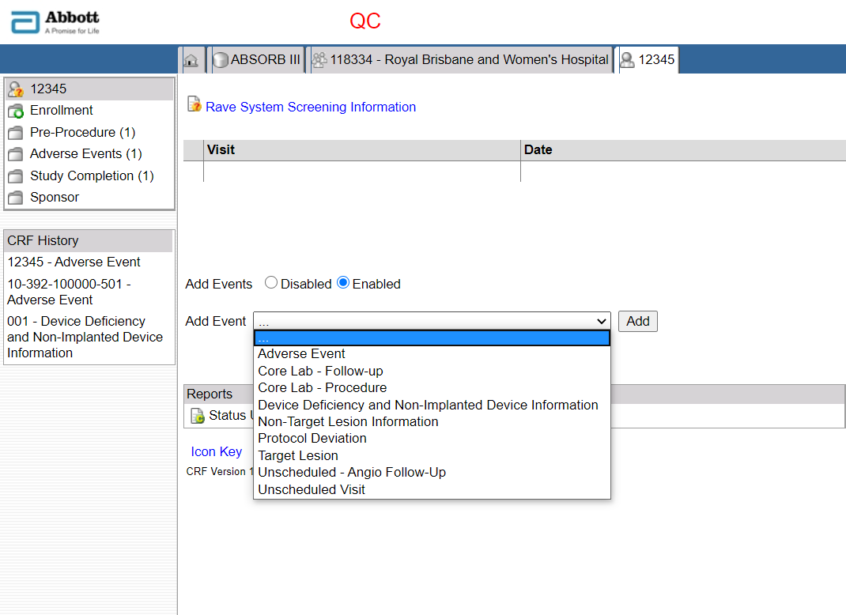

Figure Adding Forms dynamically

Select the forms and click “Add” button

1. **The Build phase of a Study:**

In the build phase of a study it is called a Project. And projects can be made and modified at the architect module of the RAVE.

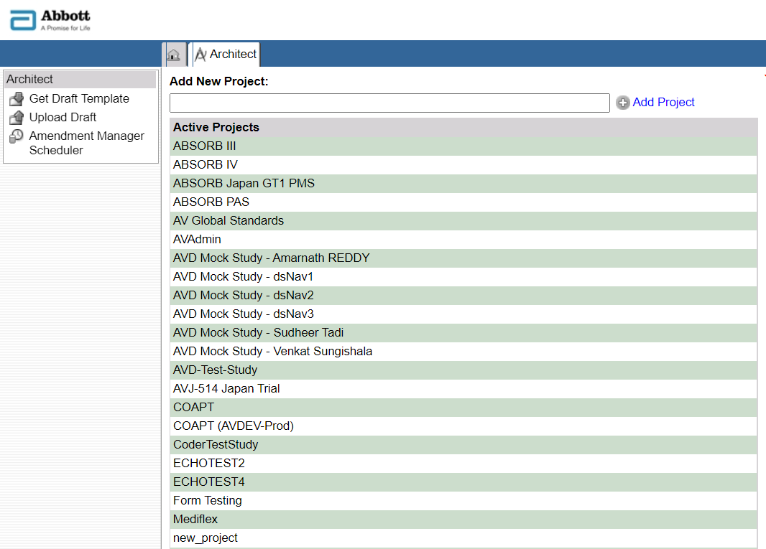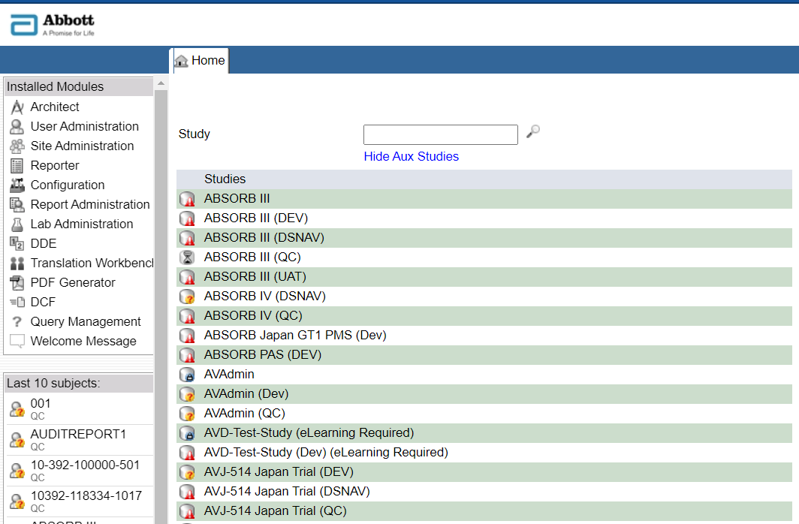9.

Active projects

Figure Existing active projects

Figure The architect module

1. **CRF Drafts and all the modules inside project:**

Let us discuss about the Architect hierarchy here. In the Architect we build a project, inside a project we create a draft, inside that draft we create forms, folders, edit checks etc whatever is needed for the Study. After building the draft we publish the draft as a version and push that version into the Study.

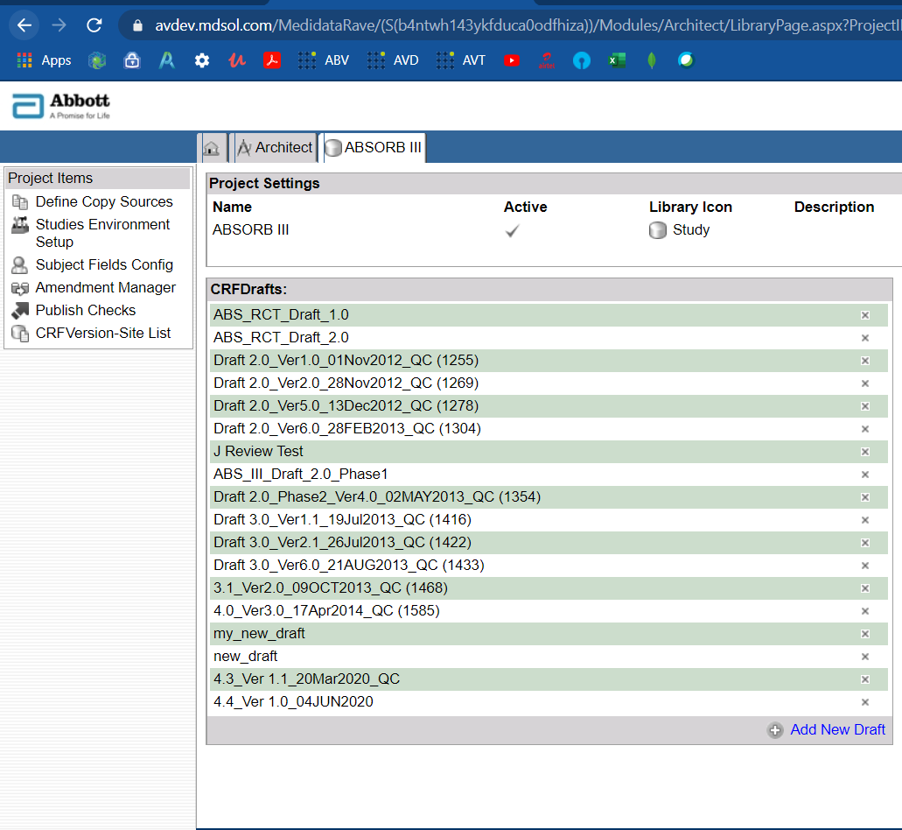

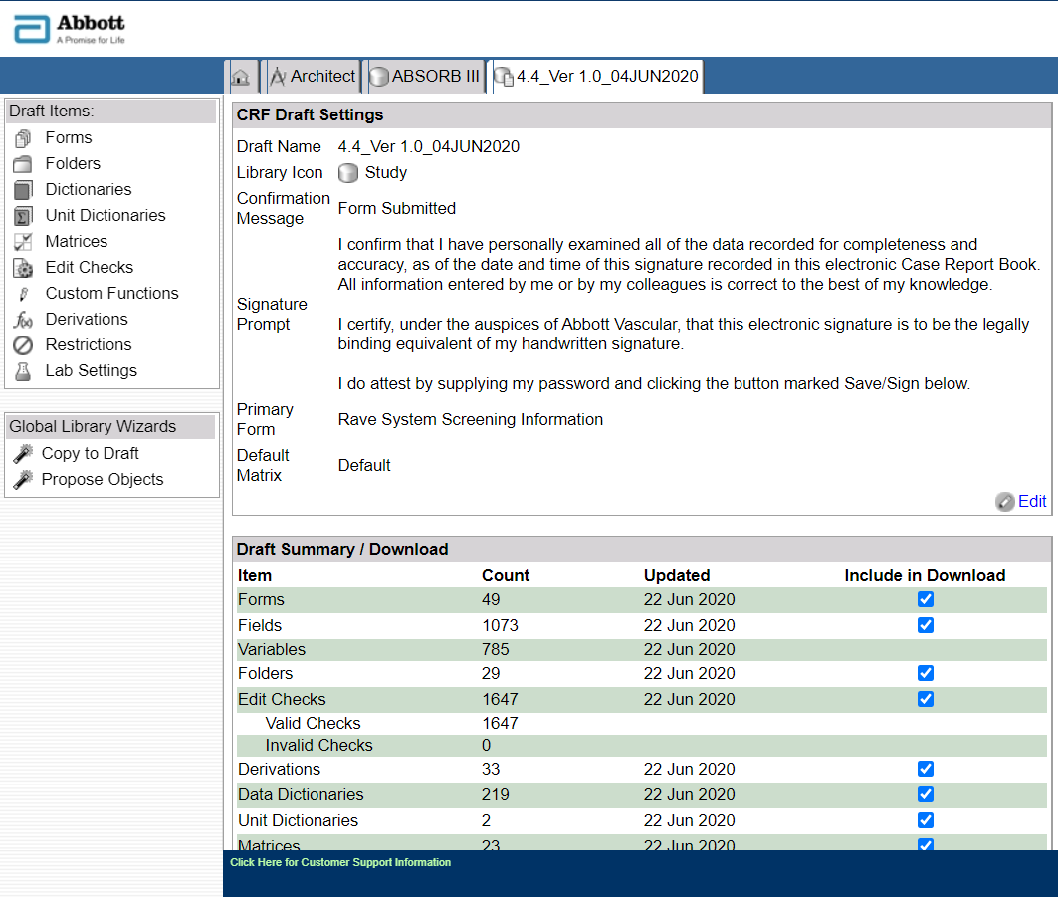

Elements of a study.

Click any of the draft to enter in that draft and to see the elements in the architectural state.

Figure Element building phase

To create a new draft

Figure Draft phase

1. **A Form Building stage and different elements of a Form:**

Since only form is the point of interest here as of now, so this part is just to give a brief regarding the form element and an insider to the form.

* 1. A form consists multiple fields.
  2. Fields are having distinctive characteristics and separated by unique OIDs

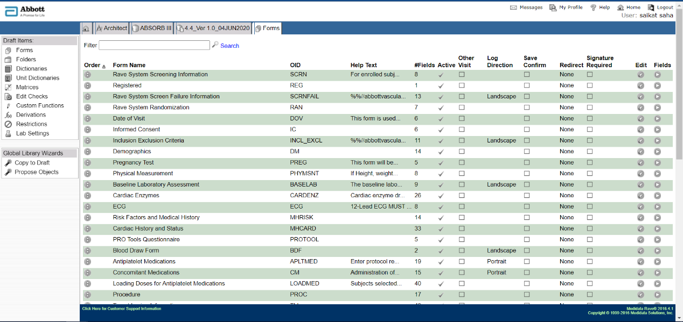

Figure 10 List of forms present in the study

Click to enter into a form

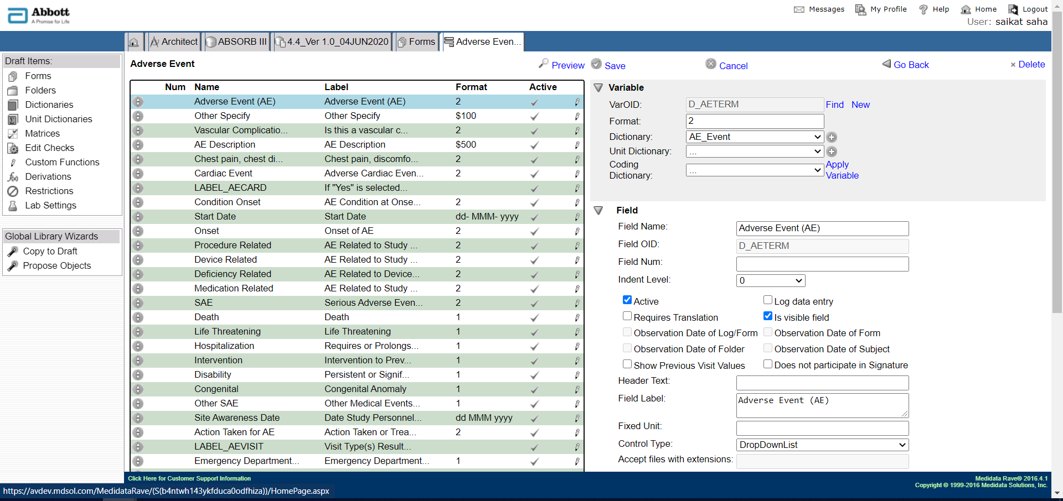

Figure Field view of a Form

xxxx

Field OID

Variable OID

Alphanumeric

Date field

Checkbox

**Note:**

1. Two fields can have similar Variable OIDs but will definitely have unique Field OIDs.
2. There are 4 datatypes
3. Numeric datatype : Only numeric values can be entered. (Sometimes radio button fields and drop down fields are also given the numeric datatype values.)
4. Alphanumeric datatypes : Both alphabets and numeric values can be entered
5. Date fields : Only date values can be entered.
6. Check boxes : Check marks can be entered.
7. **Publishing a draft to version and to study :**

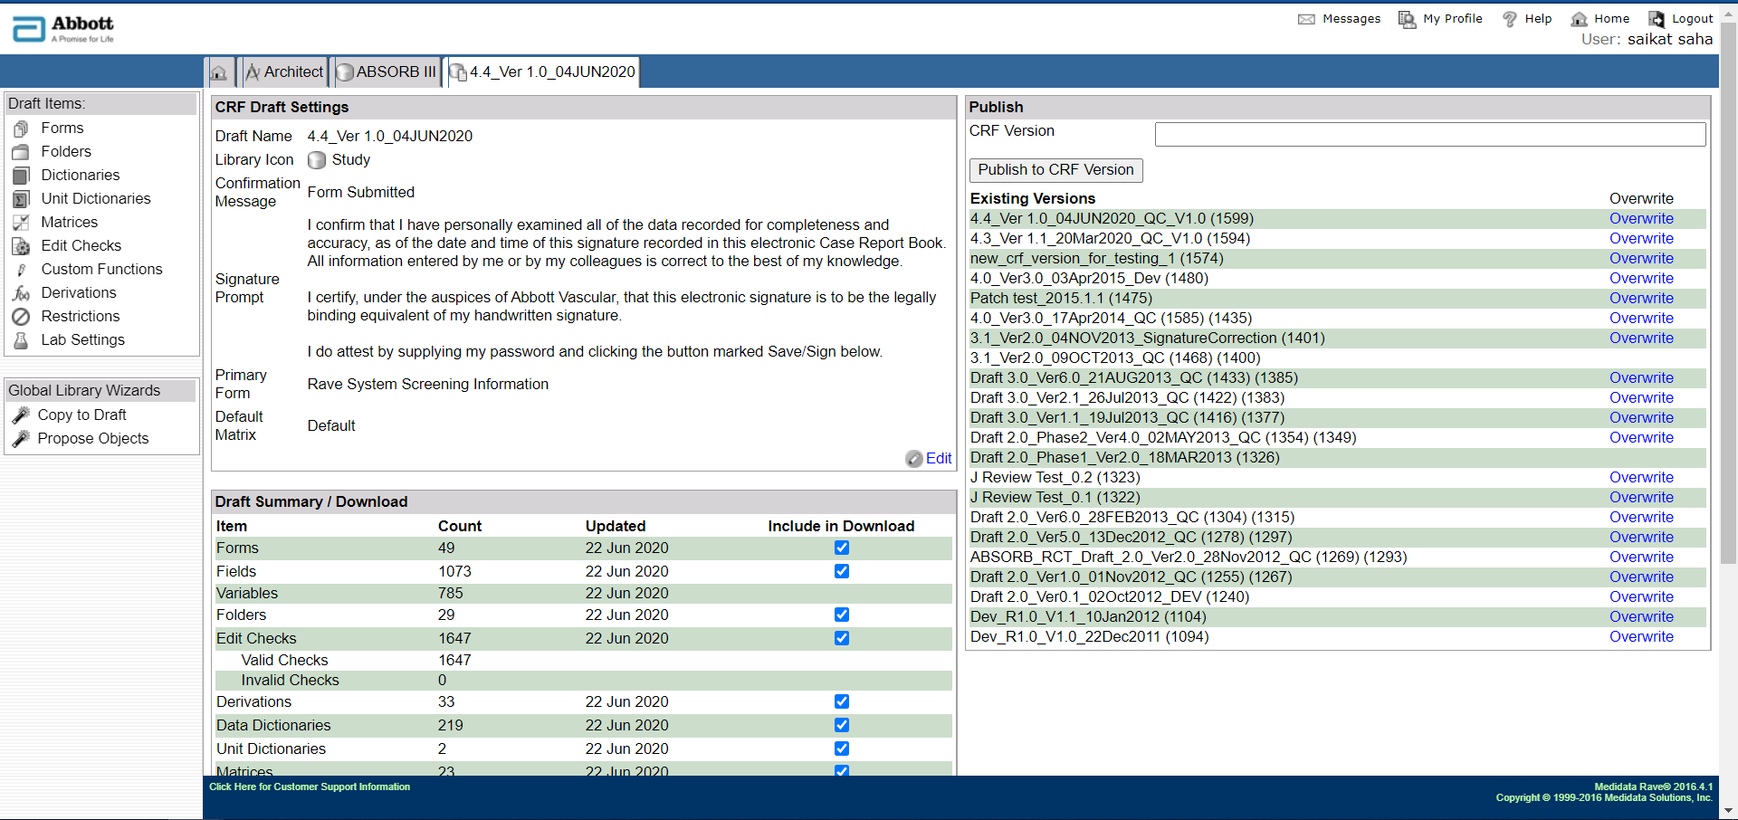

Figure 12 Creating a version and publish

Give a name to the version to be published

Click to publish the version